**Source Code Repository Document:**

**Introduction:** 1. Repository is a version-controlled storage for your project files, tracking changes with branches and commit over time.

2. It offers a powerful system for managing project history and development workflows.

(OR)

It used to store the project files, code integration at one place and tracking changes history with branches and commit the source code.

3. We have several code repository in the market.

1. SVN

2. GIT Hub

3. Bit Bucket

**GIT HUB:** 1. it is cloud based source code repository server, it is used for storage your project files, tracking changes history, code integration with branches and commit the source code.

2. Maintained by Microsoft, its available trail and commercial plans.

**GIT ENV Setup:**

-> To use GIT hub as repo server then we need to create account.

URL: <https://github.com/>

-> **Please follow below steps for create an account for GIT hub**.

-> Enter the URL in google chrome, <https://github.com/> then we can see the UI design like below.



-> Enter the email id and click on sign up.

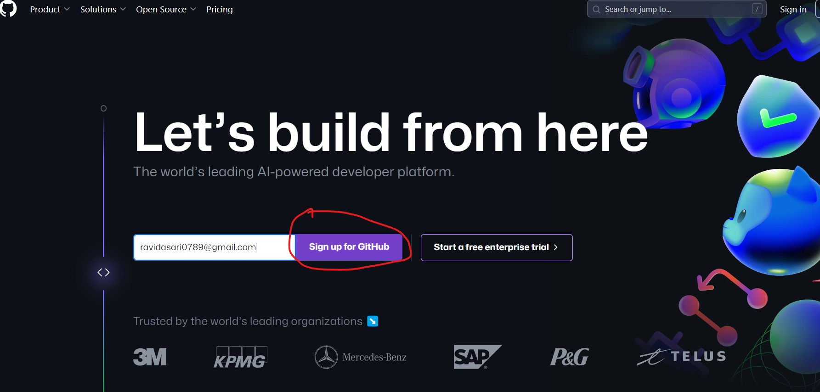

-> Then click on continue.

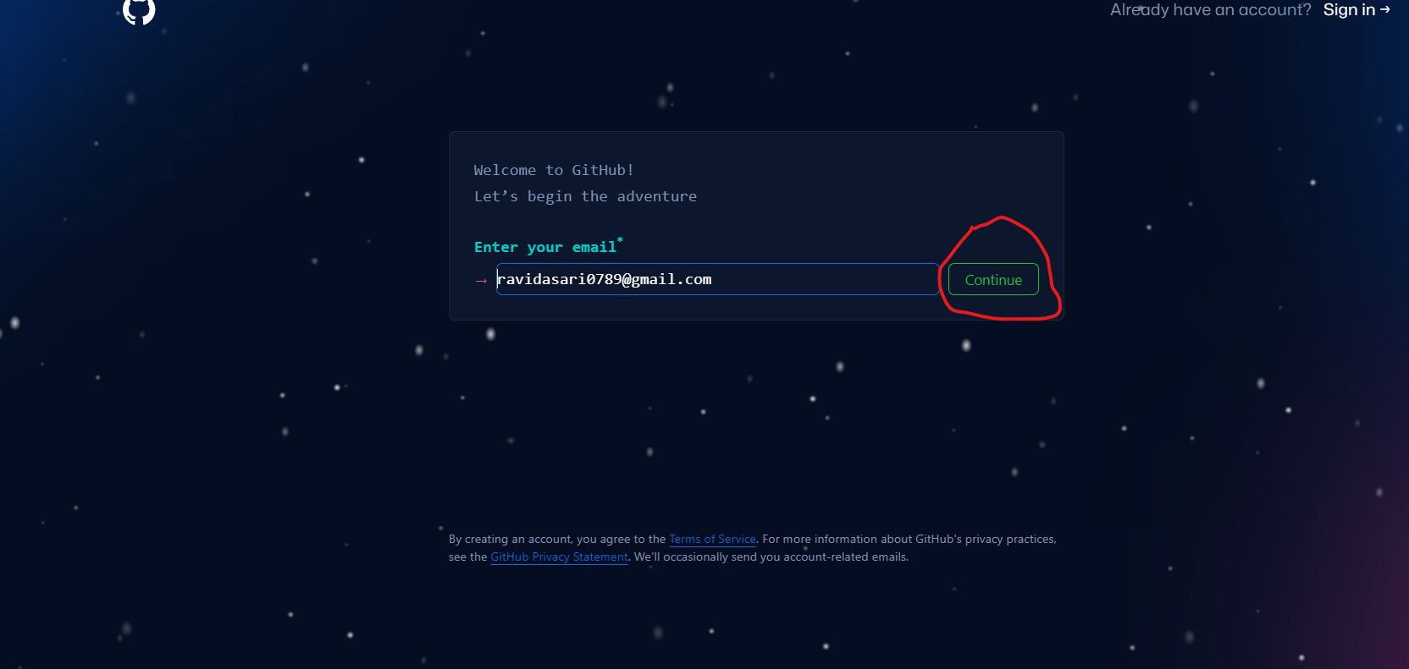

-> Enter the new password and click on continue.

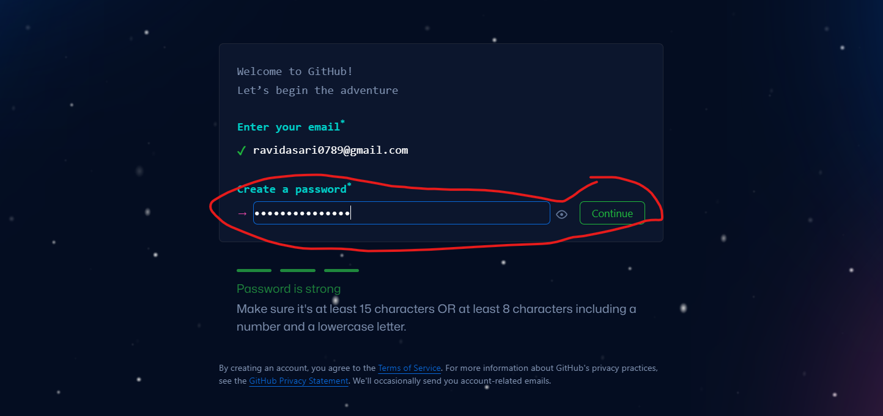

-> enter username and click on continue.

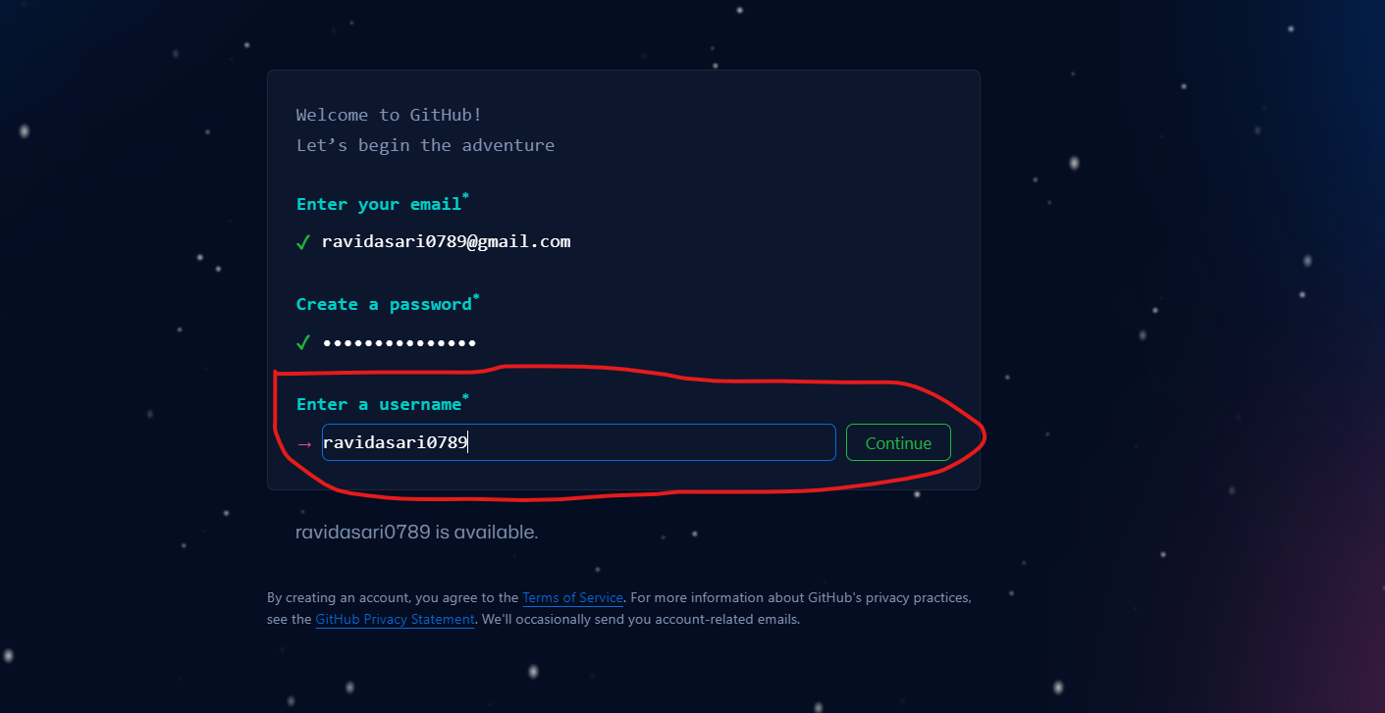

-> Then ✓ in check box and click on continue.

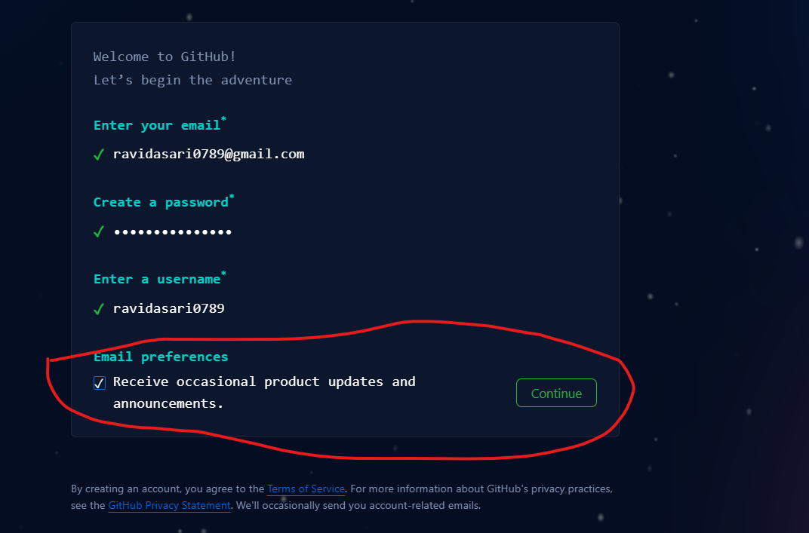

-> verify your account for security and click on submit button.

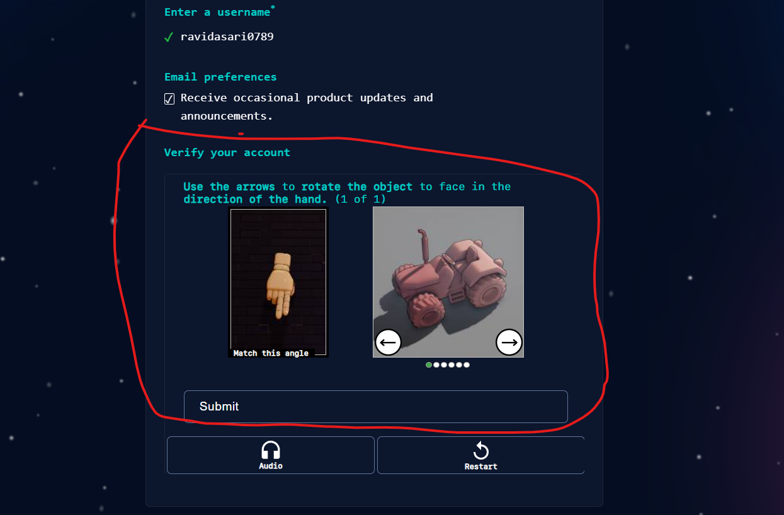

-> Once click on submit then we can see create account, then click on that button also.

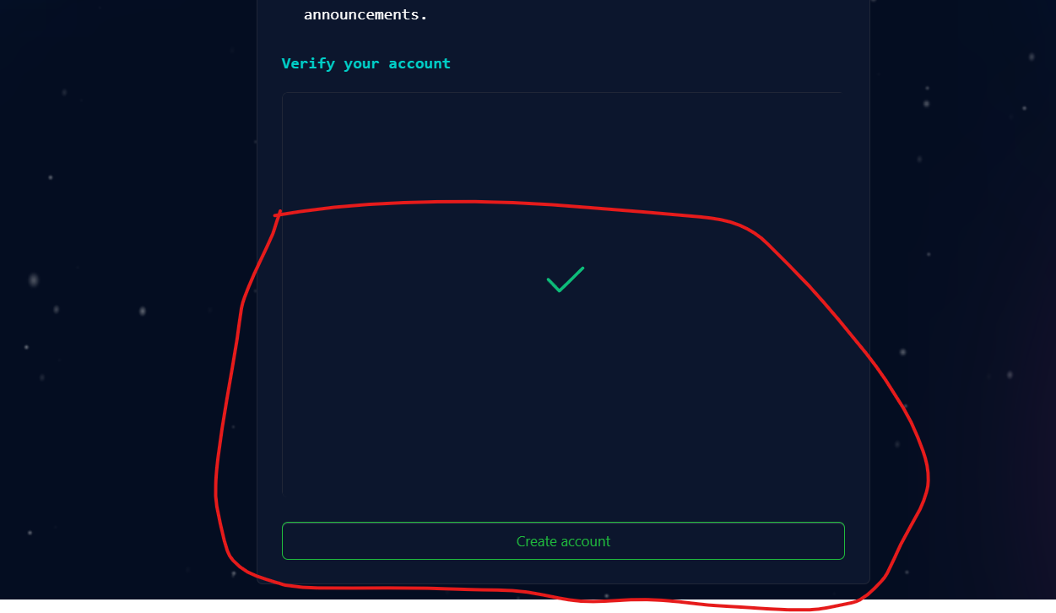

-> Once click on submit button then you can get OTP to your mail id and verify that like below diagram.

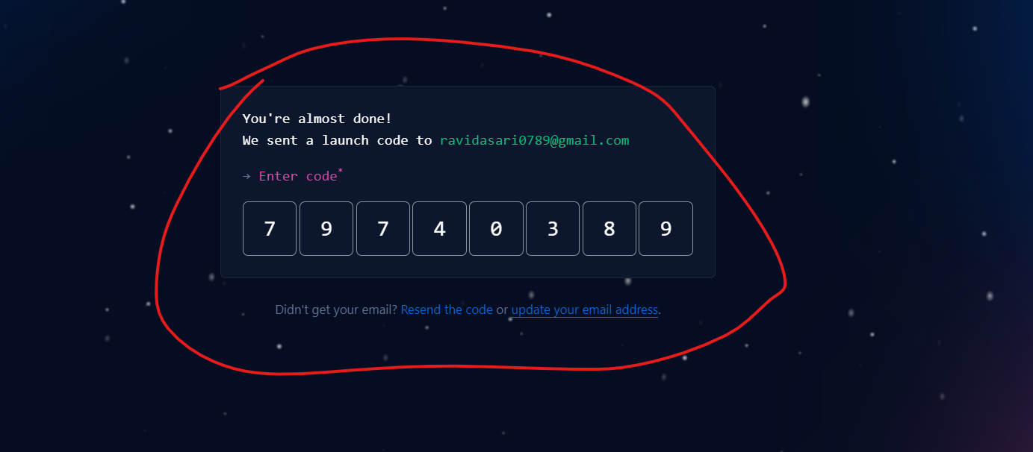

-> Once done verification then you can see welcome GIT Hub and we have questions are there left that, no need fill you have click on skip personalization.

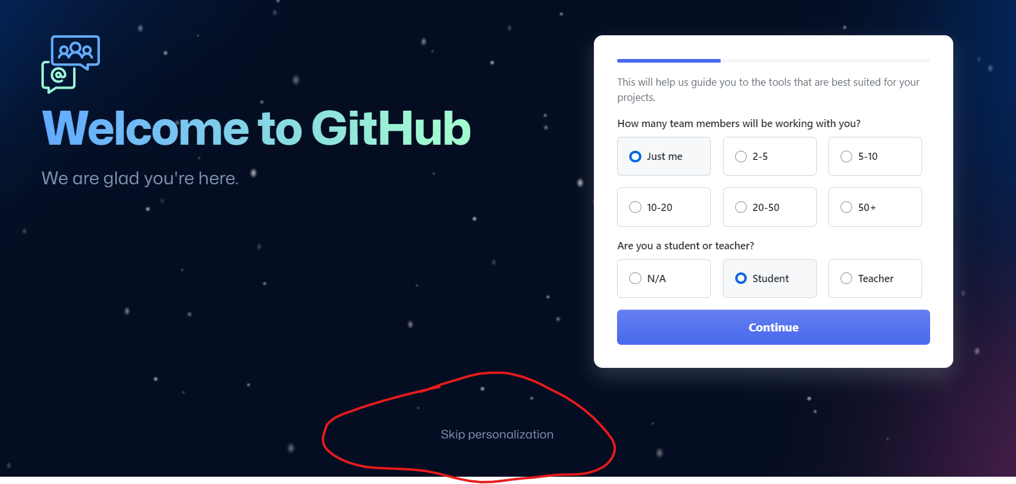

-> Once done skip then you can the dashboard like below diagram.

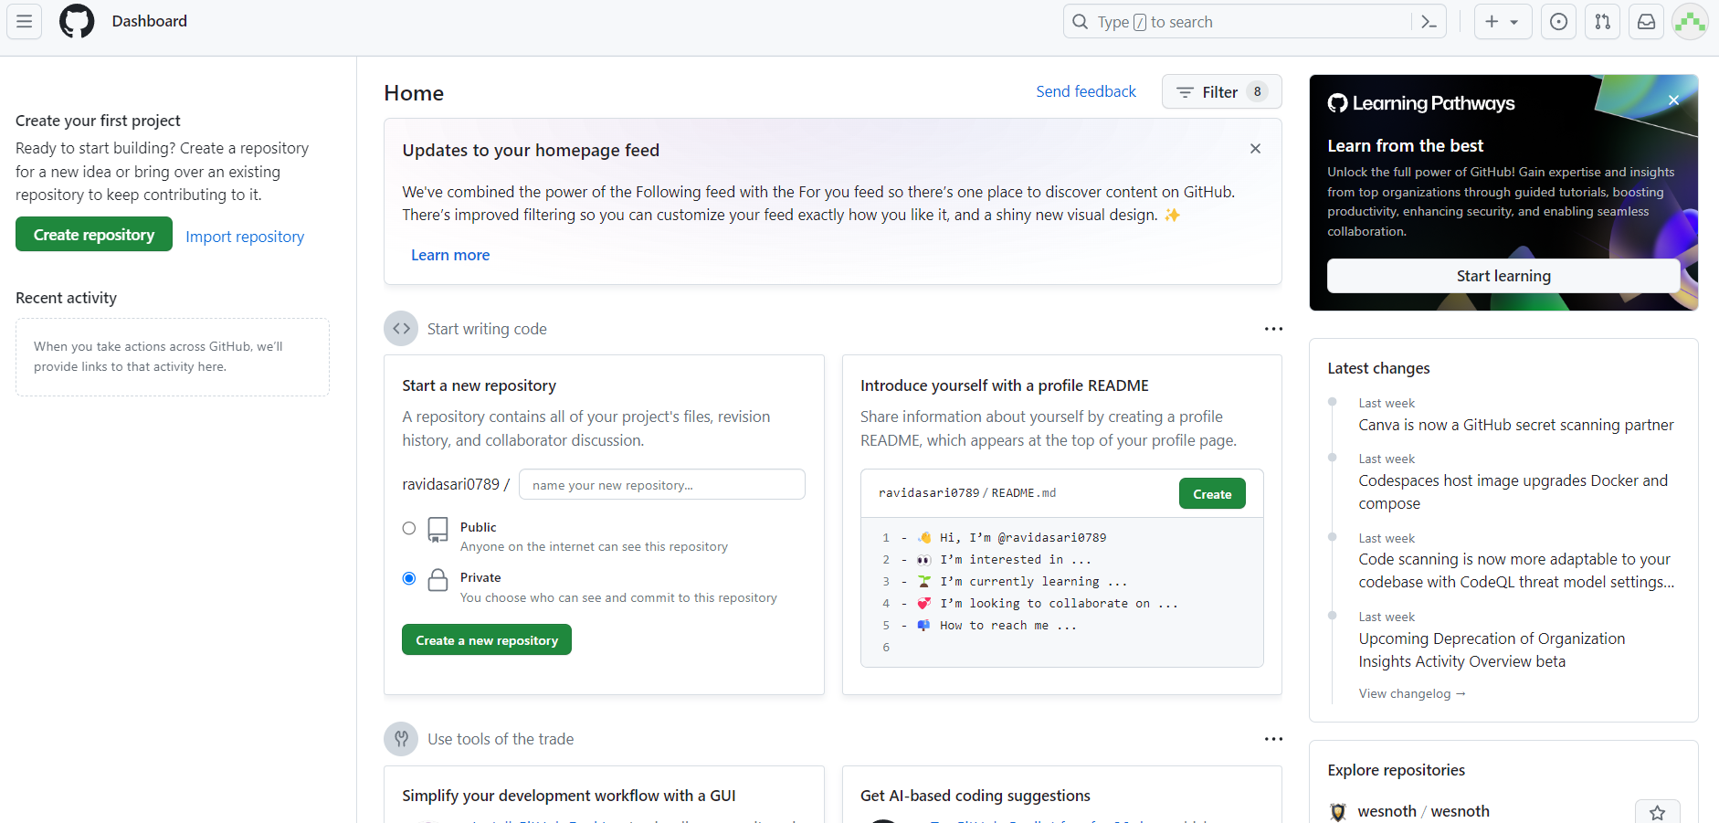

-> **Download and install GIT Client Software.**

-> Click on this URL: <https://git-scm.com/downloads>

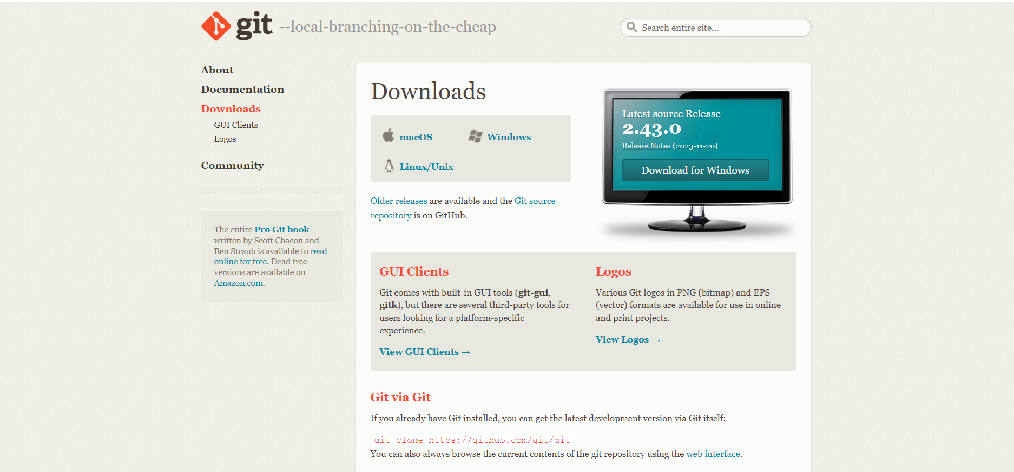

-> double click on GIT client which ever you download and click on yes.

-> Once click on yes then click on next

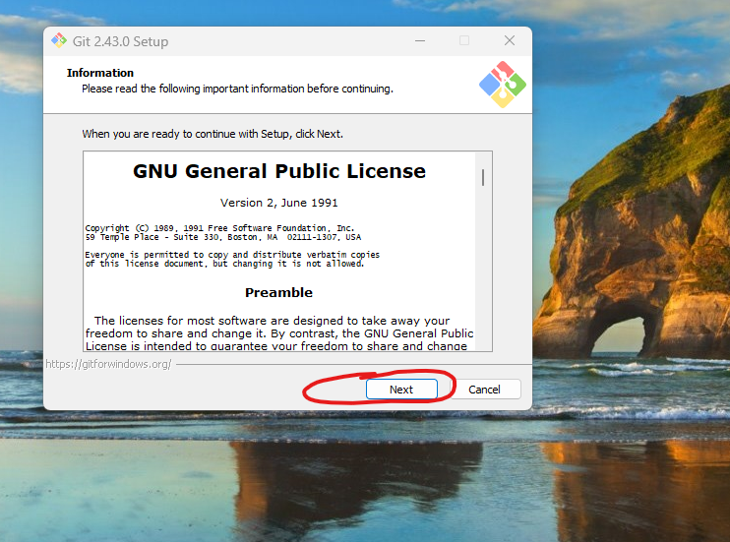

-> Click on next.

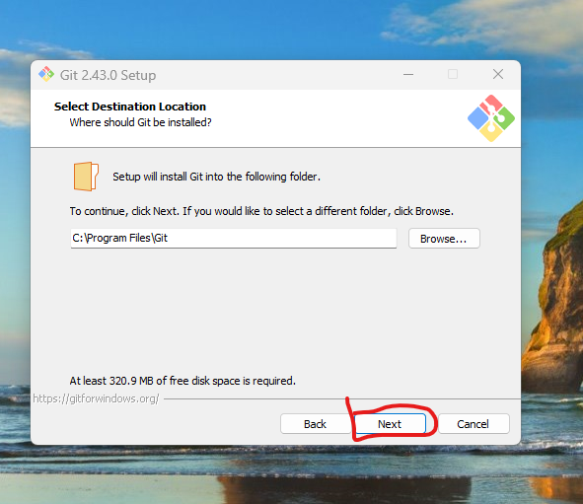

-> Click on next.

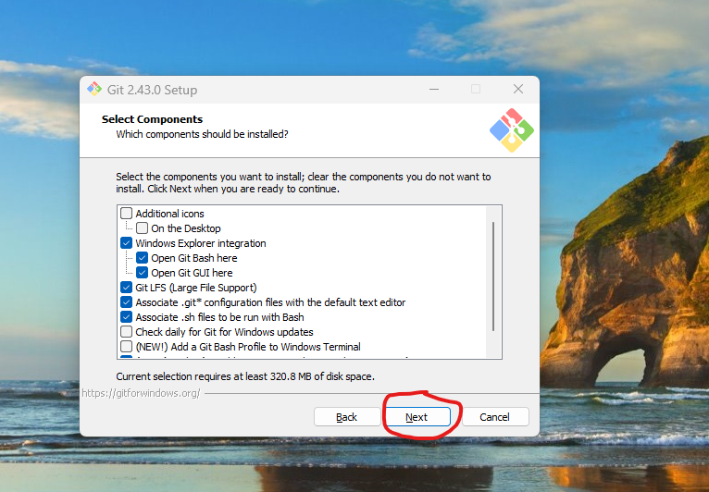

-> Click on next.

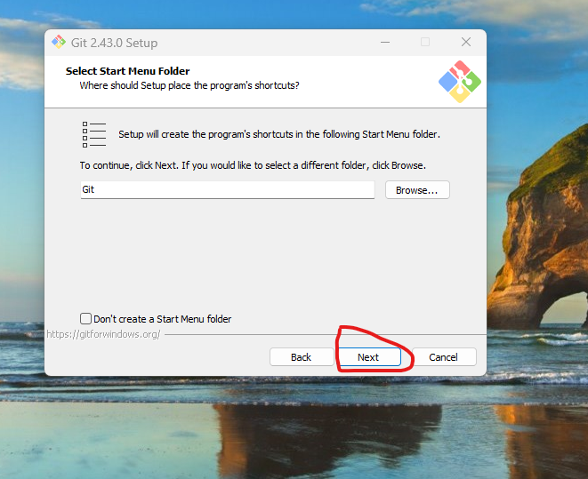

-> Click on next.

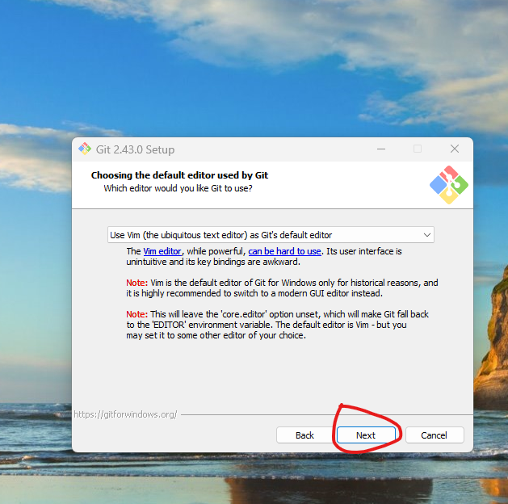

-> Click on next.

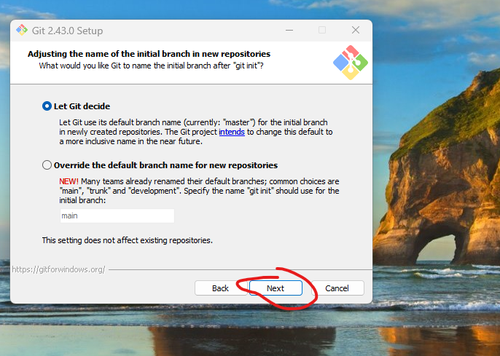

-> Click on next.

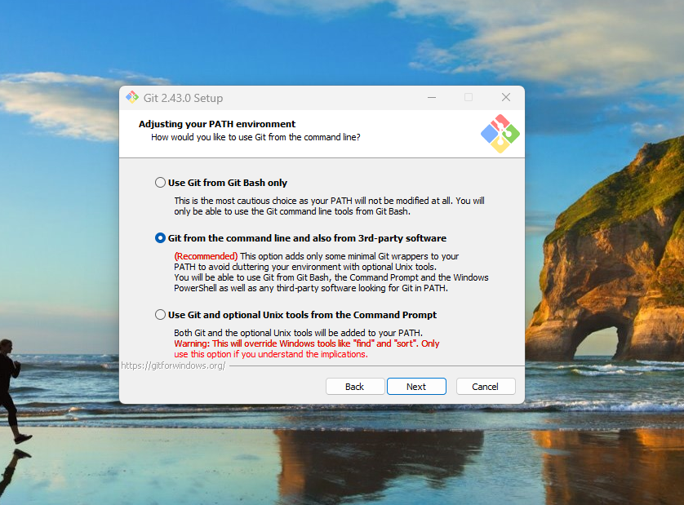

-> Click on next.

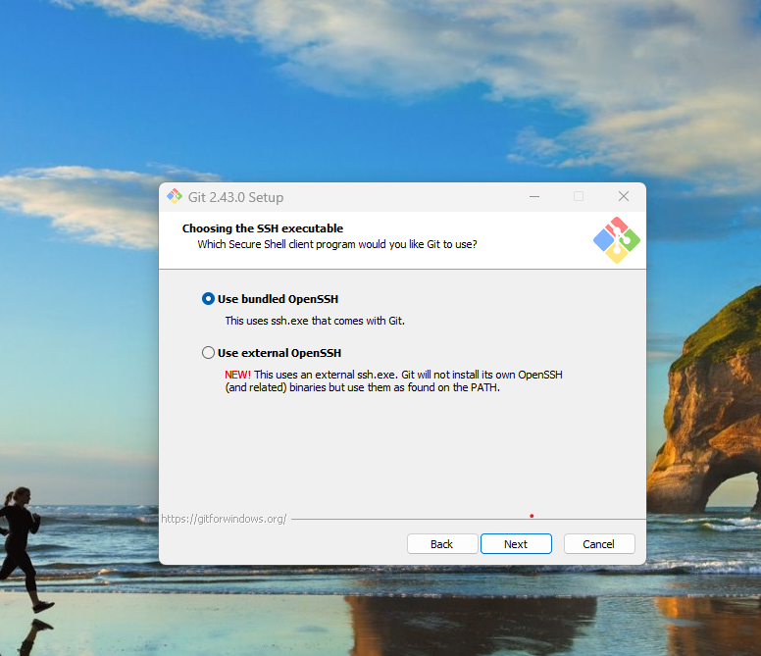

-> Click on next up to install button visible, once visible then you have select the check box and click on install.

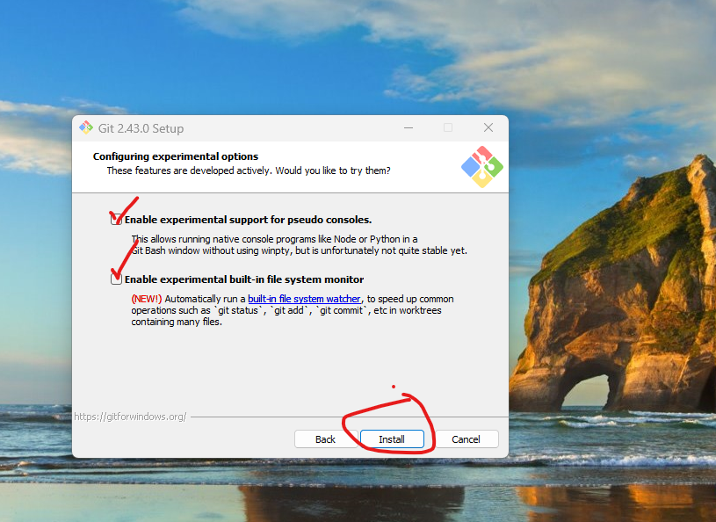

-> Click on finish.

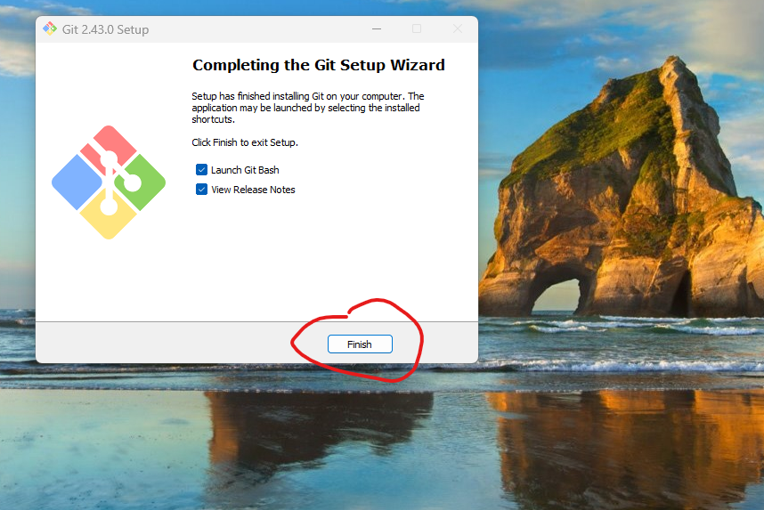

-> Right click and Open Git bash and execute below commands.

git config --global user.name "ravidasari0789"

git config --global user.email [ravidasari0789@gmail.com](mailto:ravidasari0789@gmail.com)

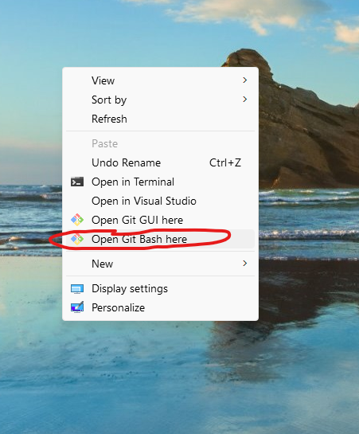

**-> Create New Repository:**

**->** Once login your git hub account then you can see dashboard, in the dashboard you can see create new repository and enter name of repository and select public and click on create repository.

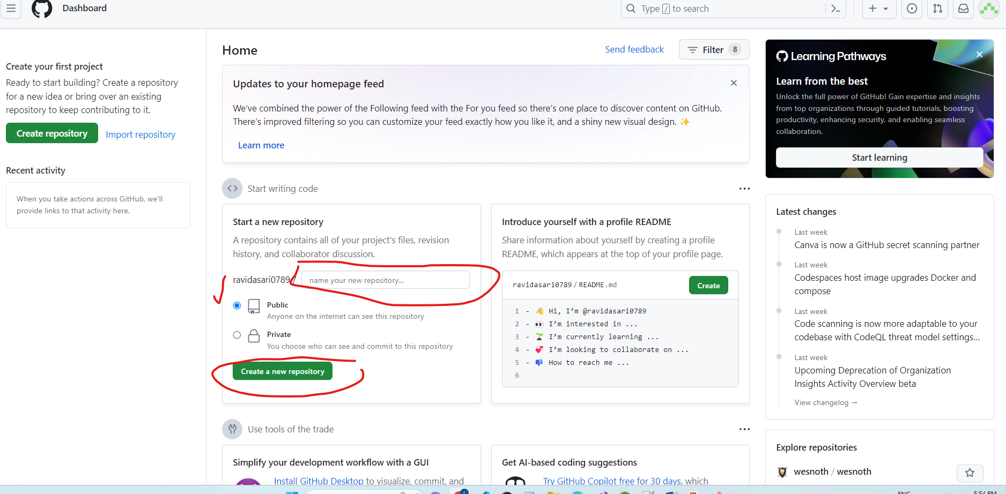

-> Go to project folder, inside folder we have to right click and click on GIT bash here.

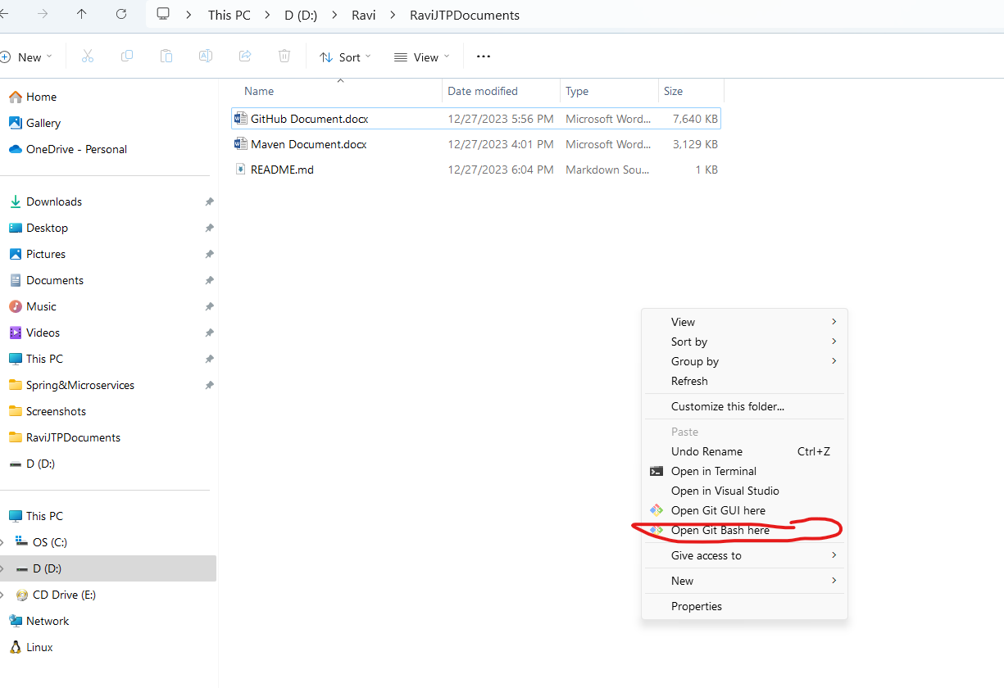

-> Once done, then open GIT hub which ever you created that one copy the commands like below diagram.

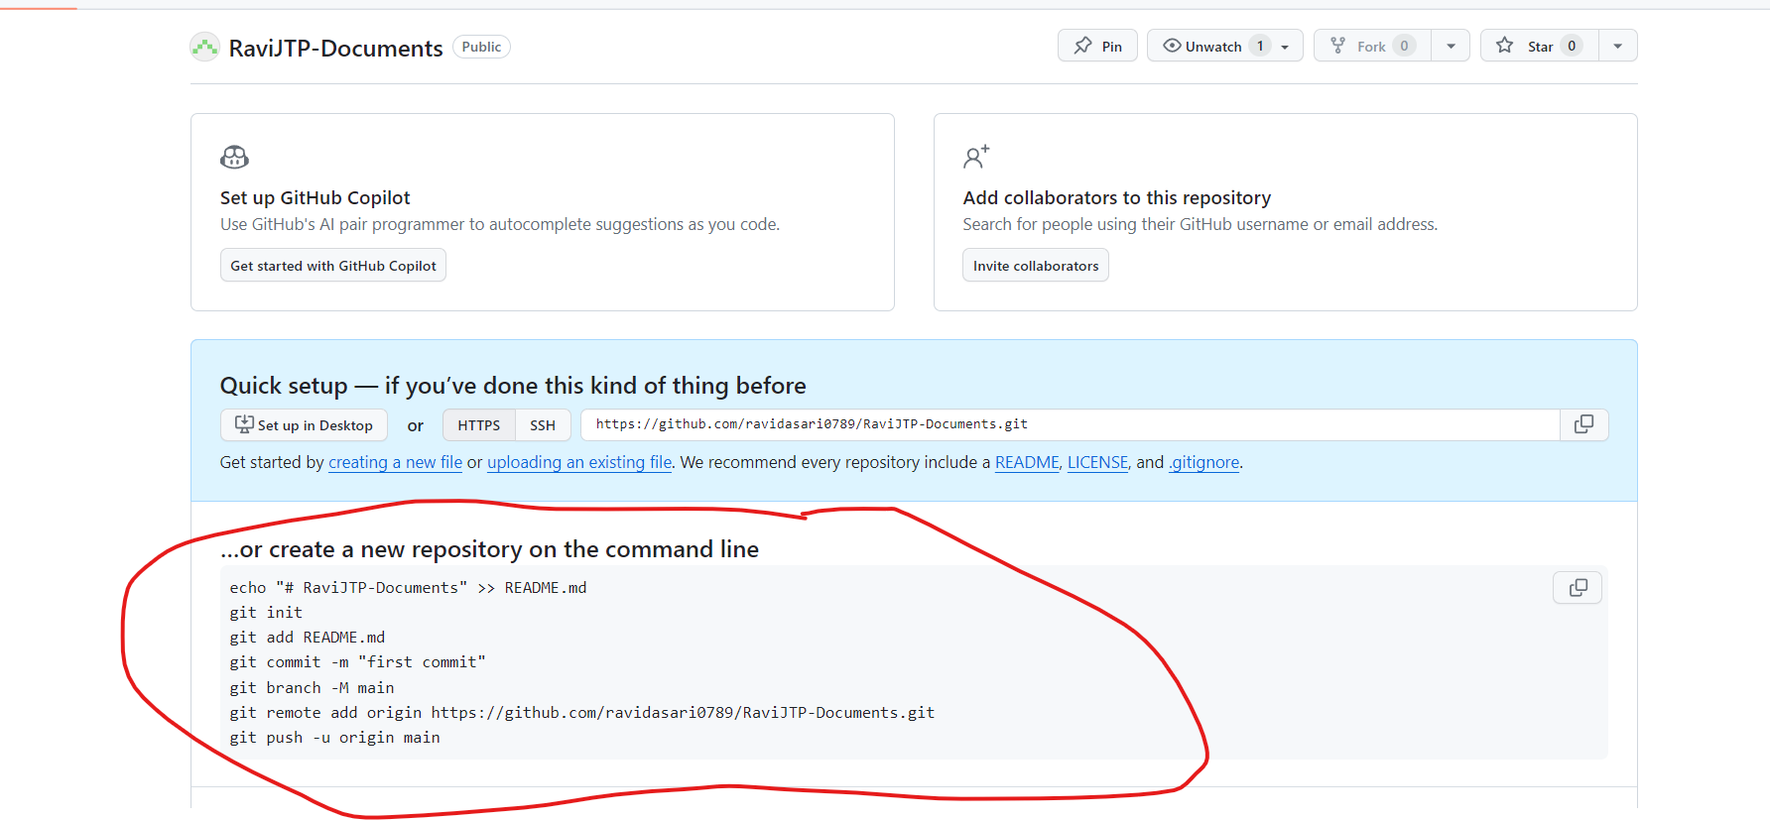

And execute that commands.

-> Once done then you have to add files and committed in local repo and whenever you are going to push files in remote repo at first time then you have to login, so it will display on pop.

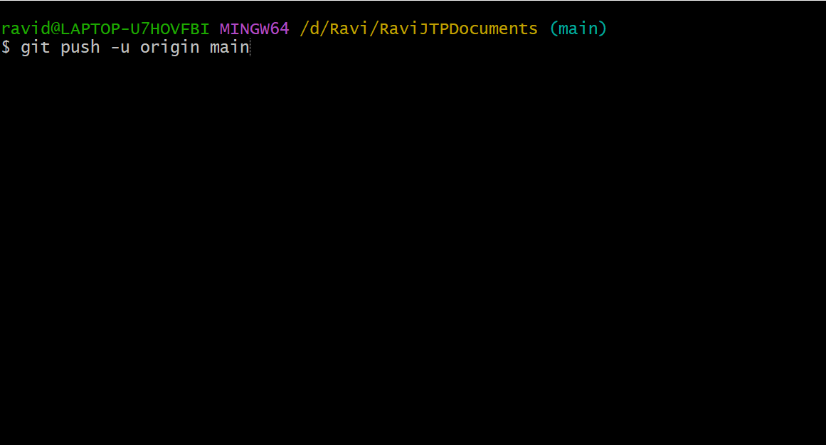

-> Whenever it display pop then you have to select sign in with browser. Once done then successfully stored in remote source code repository.

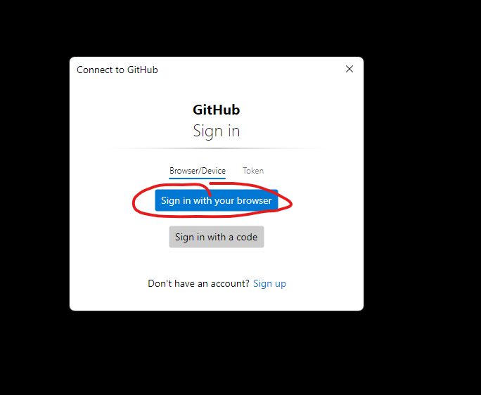

**GIT Architecture:**

1) Git Central Repo

2) Working Tree

3) Staging Area

4) Local Repo